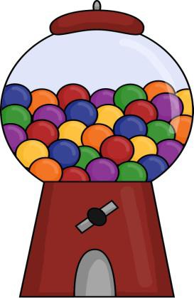
High-Frequency Words List

a | an | and | are
at | be | big | but
can | do | for | go
have | he | here | her
him | his | I | if
in | is | it | like
look | love | me | my
mom | no | not | of
pretty | said | see | she
so | that | the | too
to | this | they | up
we | was | what
who | will | where
yes | you

Activities

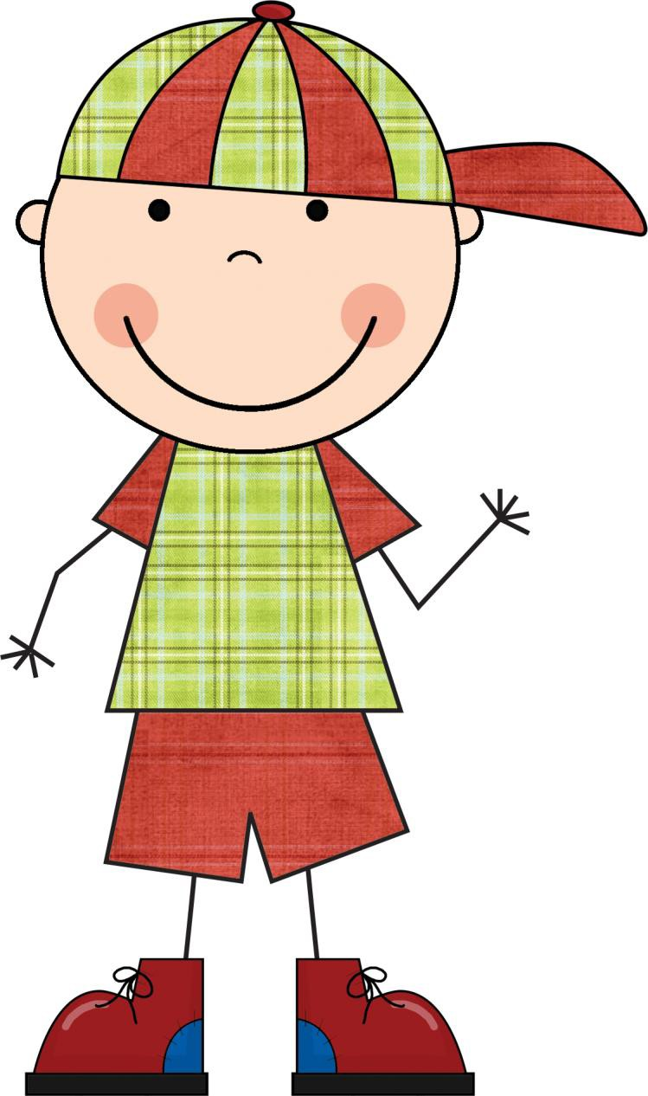

While playing, tell your child that you are

going to name two words. (EX. Bee, Tree) Then ask, “Do these Rhyme?” Continue to name words using some that rhyme and some that don’t.
Here are some great rhyming sets: Cat, Hat
Bug, jug Pig, jig Tree, bee
Mouse, house Frog, log Jump, stump Rock, sock Hill, bill
Goat, coat

First, you will need a nursery rhyme.
(We have provided a few)

You will sit with your child and read or have your child read the nursery rhyme.
you can talk about it and reread again if you would like.
Then you take the nursery rhyme and instead of reading the correct way you can substitute with other rhyming words.
Then have your child tell what is wrong with the rhymes.
This can also be done while heading to town, waiting at the Doctors, or while you are outside playing. (You can just recite the rhyme instead of reading it.)
See the next two pages for examples.

Humpty Dumpty

Humpty Dumpty sat on a wall. Humpty Dumpty had a great fall. All the king’s horses and all the king’s men couldn’t put Humpty together again.

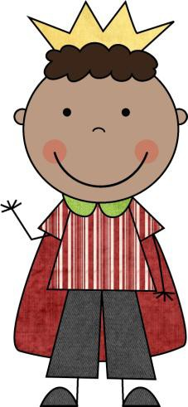

Humpty Dumpty (Altered Version)

Humpty Dumpty sat on a ball. Humpty Dumpty

had a great fall. All the king’s horses and all the king’s hen, Couldn’t put Humpty together again.

Hey Diddle, Diddle

Hey diddle, diddle the cat and the fiddle. The cow jumped over the moon. The little dog laughed to see such a sight and the dish ran away with the spoon.

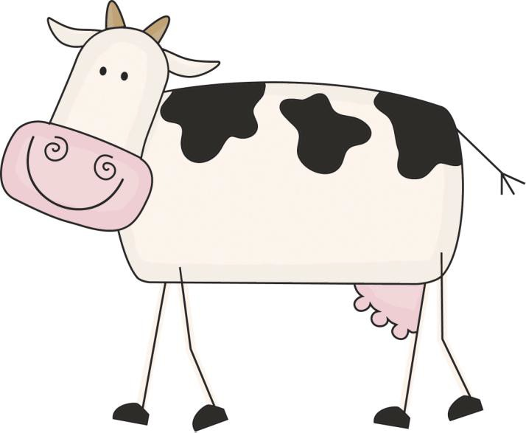

Hey Diddle, Diddle (Altered Version)

Hey riddle, riddle the cat and the fiddle. The

cow jumped over the spoon. The little dog laughed to see such a sight and the dish ran away with the moon.

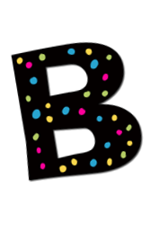
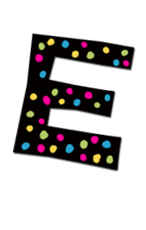
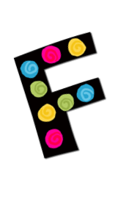
Letter Games

Listening for sounds: Say a word to your child.

Then have your child say what the beginning sound was. (Ex. Bat b-b-b) Remember to have your child say the sound and not the letter.
Name loved ones names, and have the child identify the letter sound that the person’s name starts with.
(Ex. Jill j-j-j)
You can repeat both these activities using the ending sounds as well.
Have your child listen for words that start with the same sound. If they do have the have same sound them give you a thumbs up sign. If they don’t have the same sound have them give you a thumbs down. (ex. Cat, cake. duck, bike.)

All you will need for this activity is a newspaper, book or magazine. Have your child look through and find words that start with a specific letter. Once they have found the word they can write it under the letter in the chart that is provided on the next page.

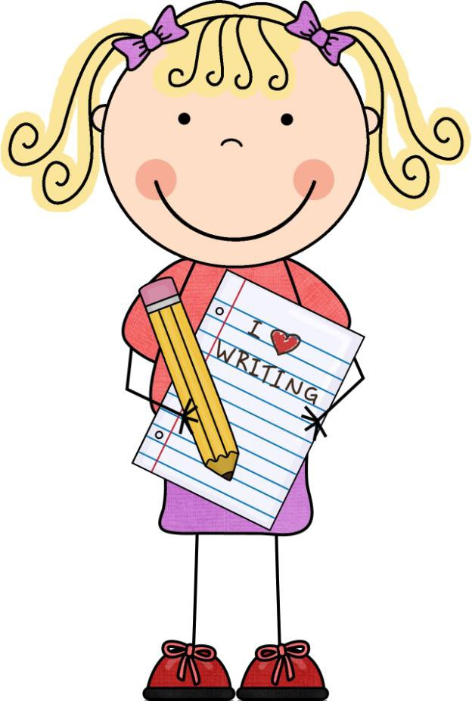

Aa | Bb | Cc | Dd
Ee | Ff | Gg | Hh
Ii | Jj | Kk | Ll
Mm | Nn | Oo | Pp

Qq | Rr | Ss | Tt
Uu | Vv | Ww | Xx
Yy | Zz |  | 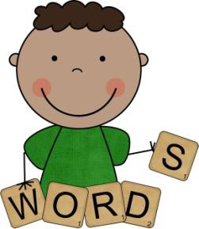

Rhyming Game

You can use the cards that are provided or make your own to play this game.

Cut the cards up and stack them in a pile.

Shuffle and deal out 3 cards leave the left over cards in the middle.

Ask your child, “Do you have a card that rhymes with______?”

If he/she has a card he/she will give you

the card if not then you will go fish and get another card.

Continue playing as many times as you like.

You can use this game with rhyming words, and words/beginning sounds. We have
provided cards for each one of these games.

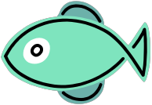
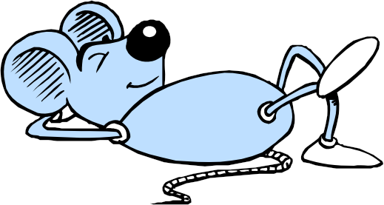
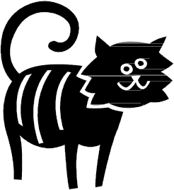
Rhyming Game Cards

Fish | Dish
House | Mouse
Cat | Hat

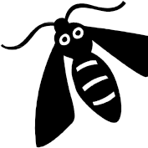
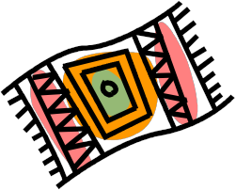
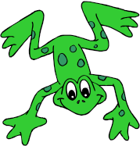
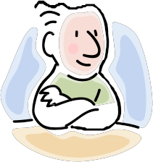
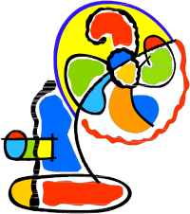
Bug | Rug
Dog | Frog
Sun | Run
Man | Fan

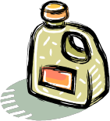
Words/beginning sounds game cards

Boat | Bb
Car | Cc/Kk
Jug | Jj
Mat | Mm

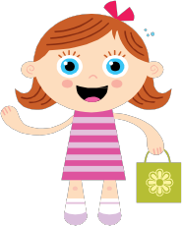
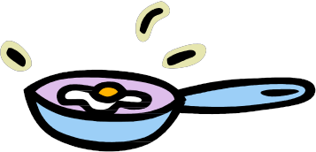
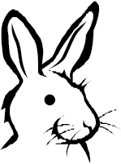
Girl | Gg
Pan | Pp
Snake | Ss
Rabbit | Rr

Matching Beginning Sounds

Go over each picture card first to make sure your child knows what each picture is.

Shuffle the cards and then place them face down in rows.

Flip over two cards to see if they match. If not try again.

You and your child should tell why the cards are a match. (Ex: A Apple. This is a match because Apple starts with Aa.)

You can play this game using the beginning sound cards, or the ending sound cards

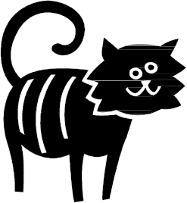
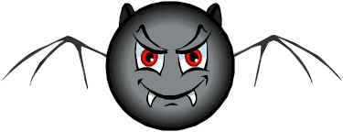
Ff | 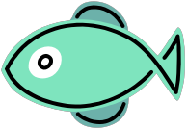
Hh
Cc
Bb

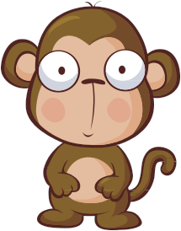
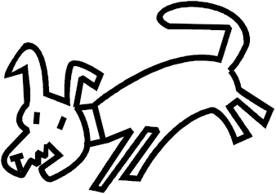
Ll | 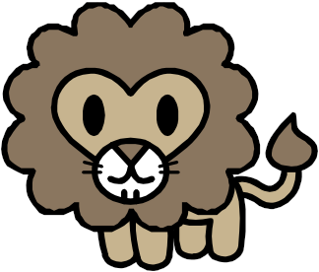
Mm
Aa
Dd

Zz | 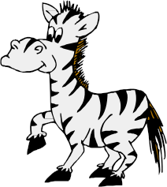
Ww
Rr
Qq

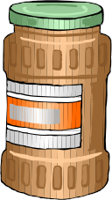
Oo | 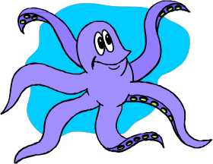
Nn
Pp | 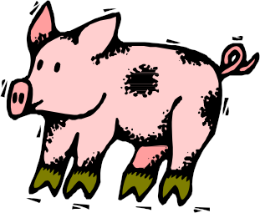
Jj

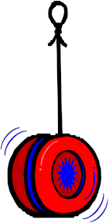
Vv
Yy
Uu
Xx

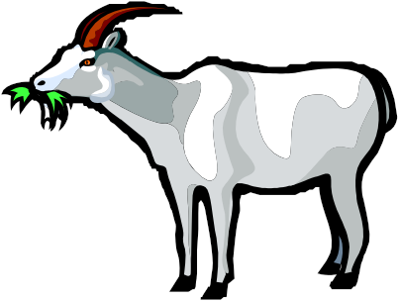
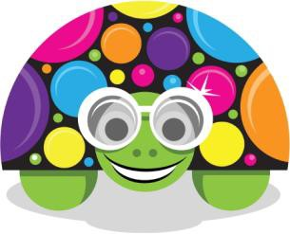
Gg

Hh

Kk

Tt

Ii
Ee

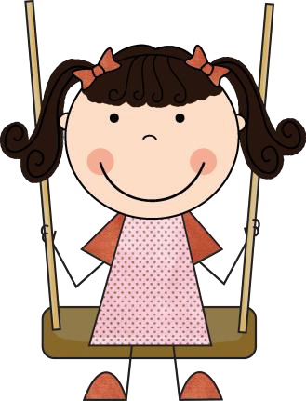
Making Words

Give your child a three letter word. Then have them make the word using letters. You can use magnetic letters or letter cards.

Here is a list of words that your child could make:

Cat hat bat mat rat sat Pig wig jig dig rig big Dog frog log hog hot pot Dot lot bug rug jug mug Cup ham jam sam ram pam Day may way say the she Her him see you
Have your child try and sound out the words by stretching the word and listening for each sound.

Math Activities

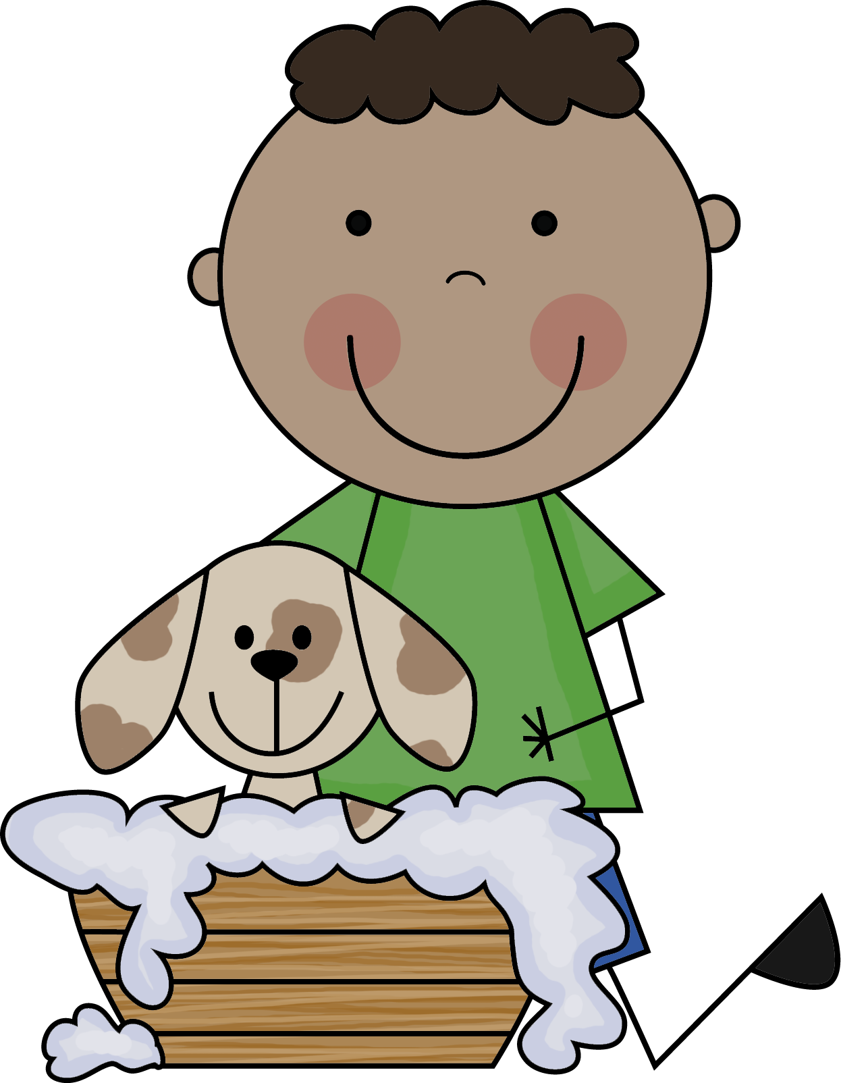

Addition

First go over the symbols used when adding. (+ =)

You can then use the cards provided and practice doing simple addition to 10.

You can make up a story: Ex.

The little girl had 2 pieces of candy and then she got 2 more pieces. How many pieces does she have all together?

If you can, have your child write the number sentence out to match the story. (2+2=4)

You can also practice adding by using many items in your house: Pennies, candy, cereal, blocks, cars, beans etc

Subtraction

First go over the symbols used when subtracting. (- =)

You can then use the cards provided and practice doing simple subtraction from 10.

You can make up a story: Ex.

The little boy had 6 pieces of candy and then he gave his friends 2 pieces. How many pieces does he have now?

If you can, have your child write the number sentence out to match the story. (6-2=4)

You can also practice subtracting by using many items in your house: Pennies, candy, cereal, blocks,
cars, beans etc

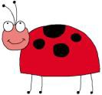
Fantastic Learning Websites

www.pbs.com There are many literacy and math activities. There is also a connection to many PBS programs.

www.starfall.com This is a great website for phonics and early reading skills.

www.cookies.com This is another great website for phonics and early reading skills. It also has science and social studies games.

http://funschool.kaboose.com/preschool/games/inex.html Cute games for all subjects and great levels.

